AI System - High Level Plan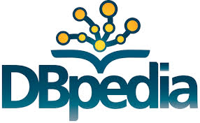

Student Profile

ANU Course Prerequisites

Degree builder

Wikipedia-enhanced Course Ontology

Degree enrolment information

Programs and Courses Data

Search Connector

Subject Interests

Wikipedia data